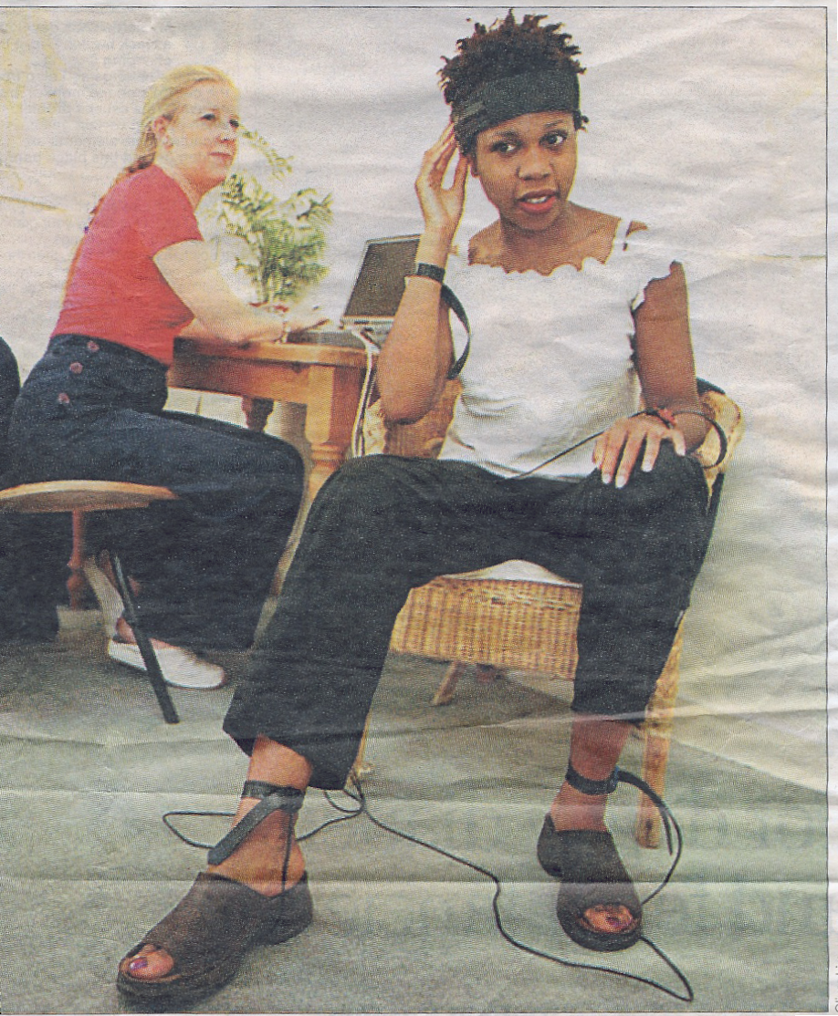
Evening Standard Health & Fitness
Tuesday 6 March 2001

The machine that can tell if you’re well

The Quantum Xrroid system is complementary medicine gone sci-fi: it thinks it can diagnose your bodily health and your moods.
Precious Williams went to find out.

THERE'S a scarily high-tech new health-testing device that's coming to a health clinic near you. If its creators are to be believed, the machine can read what is on your mind as well as what's going on in your body. The Quantum Xrroid system - QX for short - is a computer linked arrangement that's just arrived in the UK and is
Wired for health: Precious Williams connected to
the QX machine, operated by Susan Astbury.
tipped to revolutionise complementary medicine.

Developed by a former Nasa scientist, Professor Bill Nelson, QX works by measuring your body's "electrical parameters". Using ultra-sensitive computer software, the device "reads" your physical and emotional vibrations. In short, it can tell you whether you are healthy at a click of the mouse. It's also capable of analysing your physical reactions such as allergies to more than 3,500 different substances.
Jayney Goddard, president of the Complementary Medicine Association, says: "Humans are naturally electrical beings and the QX system accurately measures the patient's electrical responses.
The device uses electrophysiological reactivity to pick up sensitivities and identify the overloading of specific substances and toxins."
At the Grove Health Clinic in Kensington, QX practitioner Susan Astbury strapped electrical cables to my head, ankles and wrists (this is painless, if slightly uncomfortable). The cables are wired to Susan's state-of-the-art laptop.
No pulse or blood pressure readings are taken. Instead Susan types details of my sleeping, eating and working patterns straight into the computer. In a matter of minutes, the QX machine will have tested my body's electro-magnetic parameters for signs of allergies, vitamin-and-mineral deficiencies, viral and bacterial infections, parasites and even adverse moods and emotions.
"Strong emotions are capable of causing physical reactions, which, thanks to this system, can now be measured," says Susan, typing furiously. "With ailments which are difficult to treat, like migraines, QX can determine whether the underlying problem is

sugar toxicity or simply high stress levels.
The readings allow me to pinpoint your body's precise requirements and prescribe tailor- made treatments for you."
Seconds later, my "vibrational energy" details are digitally analysed and displayed on-screen in easy-to- read jargon. The QX machine has revealed a reassuringly high level of overall physical and emotional health.
But it isn't all good news. According to the QX analysis, I have higher-than-healthy stress levels (hardly surprising, with my constant rush to meet deadlines). My level of patience is markedly low (something
my boyfriend tells me every day). The machine then churns out a personalised allergy-elimination programme. Again, it is uncannily spot-on in its suggestion that my body was reeling from recent overloads of alcohol, sugar and tobacco. In the week before my appointment, I'd been to six booze-laden parties and gone back to smoking 10 cigarettes a day.
What I wasn't prepared for was to be told that the real enemy to my health was carrot juice. If QX is to be believed, my daily trips to the juice bar are counter-productive. The levels of carotene in my body are even more toxic than the nicotine.
The final stage of the QX treatment involves a five-minute interlude during which electro-magnetic resonances are zapped throughout my body (again, this is painless, but just try keeping a straight face). These resonances, says Susan, will temporarily rebalance the chakras. But for longer-term health benefits, she suggests I return to the clinic for a few sessions of colour therapy. QX advocates a holistic approach to health prevention rather than cure. According to this philosophy,

there's no point in indulging in quick-fix cures since you'll simply overload your body
rather than improving the underlying electro physical vibes. "There's a definite validity to QX," says Jayney Goddard. "It's impressive. I feel that the system should be rolled out to all GP clinics." However, QX is not without its critics and Professor Edward Ernst of the Royal College of General Practitioners was quick to assure me that QX therapy was, at best, a waste of cash. "It may sound good in principle but the notion is pretty implausible. There is no evidence I have ever heard of to suggest for a minute that this system is effective," says Professor Ernst. "If a patient is suffering from illness he must see his GP. To put such claims out there about this machine's alleged capabilities is misleading and potentially dangerous."
I can't imagine the average GP investing in a QX machine: prices start at £10,000. But, for myself, the results were accurate and the dietary recommendations (no cheese, less alcohol and carrot juice) have been effective. After two weeks of sticking to the advice I've lost 4lb and acquired a glowing complexion, so I think I can safely skip the colour therapy.
QX System consultations are available at The Grove Clinic,
182 Kensington Church Street, W8 (020 72212266). Prices start at £65 for an initial consultation and £43 for subsequent readings.

SPL021

