feature profile

M

Morgan Judy Rose –
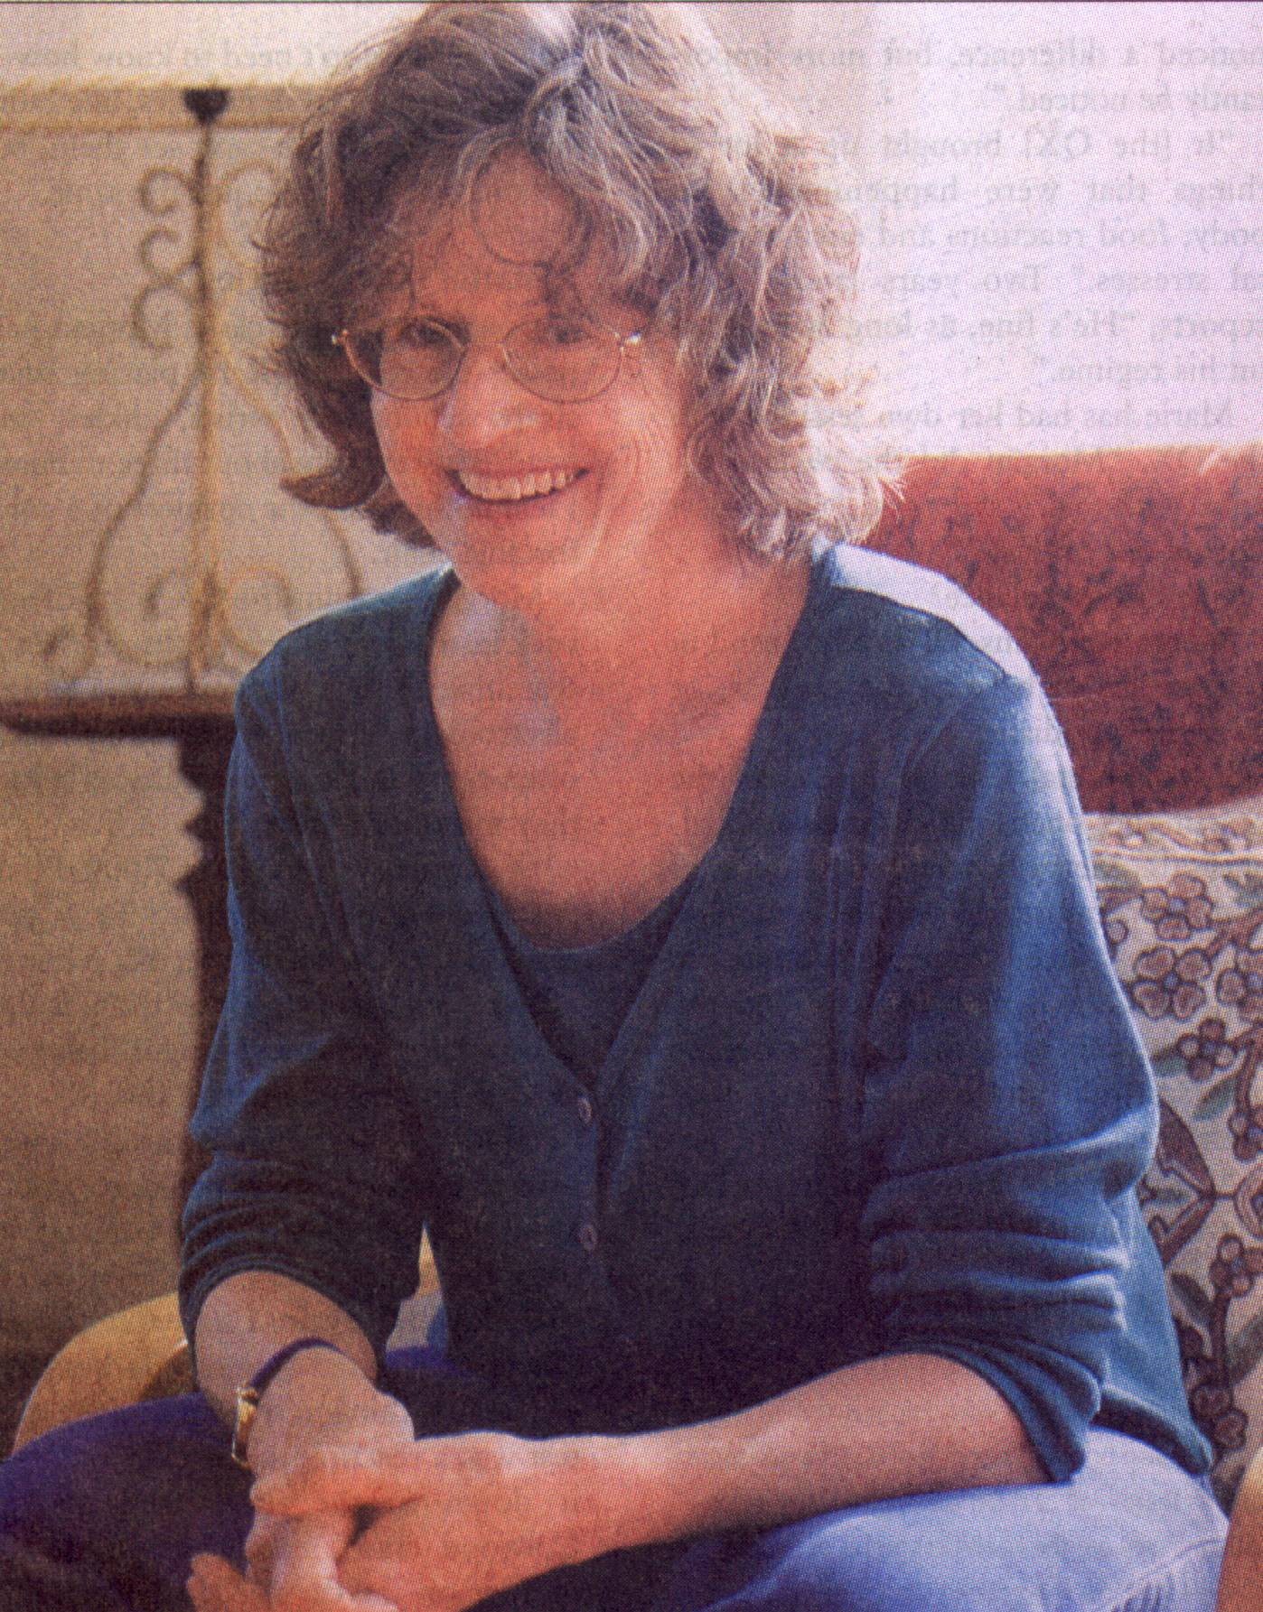
hi-tech healing BY KARYN WOODLAND
organ Judy Rose has been
practicing acupuncture since the early 80’s, when it was still relatively new to the West, and not widely embraced by the authorities. She recalls the RCMP closing down the clinic of a colleague for “practicing medicine without a license.” We’ve come a long way. And so has acupuncture.
A licensed acupuncturist, Morgan also holds a diploma in traditional Chinese medicine (trained in the Five Element System). Like all acupuncturists, she works with energy, the chi or life force, which flows through our bodies. “Conventional” acupuncture seeks to unblock and balance this chi, usually through the insertion of needles to specific meridian points.
But Morgan no longer treats her clients using needles. Today she uses a computer. “I never really liked inserting needles in people anyway,” she laughs.
Morgan is a bright-eyed woman with a ready smile and an enthusiasm for helping. We sit in her sunny kitchen with a cup of tea – she loves to brew her own from anise-hyssop gathered from her garden, but today we indulge in a cup of black tea rich with ginger. Shortly we will go downstairs to her newly-renovated clinic on the ground floor of her View Royal House.
“Having worked in clinics for 15 years, I very much enjoy working at home. I love to garden and spend time with my grandchildren (a three-year-old and a nine-month-old) and,” she smiles, “taking three seconds to go to work is really appealing.”
How did she get started?
“In theatre,” she says with a laugh. She’d planned to follow in the footsteps of her mother, an actress. Her early training was in theatre and music, at London’s Guildhall School of Music and Drama. “But my uncle-he has passed on now-was a spiritual healer, and he would have people

come from all over Europe. When I was about 15 he told me I had the same gift but at that time it didn’t seem very cool and I ignored it,” she says with a grin. “I was much more intent on being a famous actress.”
In her 20’s, after working on a television program, she had made enough money to come out to Canada with her cousin. She stayed in Vancouver, working in the theatre and teaching theatre in schools, and in the 1970’s (by then married with two children) moved to Vancouver Island.
“It was at that time, when I was thirty-something, that I went back to England and my uncle asked me to join him in a research project on spiritual healing that was being conducted by scientists,” Morgan tells me. The “healers” would place their hands on “patients” who were hooked up to biofeedback equipment, “and they’d record how all the dials changed. When I saw this I realized I wasn’t using a gift that I’d been given.”

Once home again, she started doing just that and, “as the universe works-people started to come. I called it spiritual healing; I didn’t know what else to call it-I think it was something like Reiki and the laying on of hands that have been done for centuries,” she tells me.
But it didn’t earn her a living, so she went to acupuncture school. “In those days a lot of people hadn’t heard of it-they looked at me in horror and say, “You stick needles in people? Gross!”
A pioneer in energy medicine, Morgan is currently the only practitioner in Victoria using a computer software program known as the Quantum Xrroid (QX) to help her clients achieve optimal health and well-being. Call it hi-tech healing: marrying the ancient art and knowledge of Chinese medicine with the sophistication of 21st century science and technology.
How did she go from “putting needles in people” to using a computer?

M

